**20MCA241: DATA SCIENCE LAB**

**LAB CYCLE 1**

**EXERCISE 1: Introduction to Numpy**

1. Write a NumPy program to create an element-wise comparison (greater, greater_equal, less and less_equal) of two given arrays.
2. Write a NumPy program to create an array of all the even integers from 30 to 70.
3. Write a NumPy program to create a 3x3 identity matrix.
4. Write a NumPy program to create a vector with values ​​from 0 to 20 and change the sign of the numbers in the range from 9 to 15.
5. Write a NumPy program to create a 5x5 zero matrix with elements on the main diagonal equal to 1, 2, 3, 4, 5.
6. Write a NumPy program to compute sum of all elements, sum of each column and sum of each row of a given array.
7. Write a NumPy program to save a given array to a text file and load it.
8. Write a NumPy program to check whether two arrays are equal (element wise) or not.
9. Write a NumPy program to create a 4x4 array with random values, now create a new array from the said array swapping first and last rows.
10. Write a NumPy program to multiply two given arrays of same size element-by-element.

**EXERCISE 2: Matrix operations (using vectorization) and transformations**

Write Python program to create two matrices (read values from user) and find the following

1. Dot Product

2. Transpose

3. Trace

4. Rank

5. Determinant

6. Inverse

7. Eigen values and eigen vectors

**EXERCISE 3: Programs using Matplotlib**

1. Draw a line in a diagram from position (1, 3) to (2, 10) then to (6, 12) and finally to position (18, 20). (Mark each point with a beautiful green colour and set line colour to red and line style dotted)

2. Draw a plot for the following data:

|  |  |
| --- | --- |
| Temperature in degree Celsius | Sales |
| 12 | 100 |
| 14 | 200 |
| 16 | 250 |
| 18 | 400 |
| 20 | 300 |
| 22 | 450 |
| 24 | 500 |

3. Write a Python program to draw a line using given axis values taken from a text file, with suitable label in the x axis, y axis and a title.

4. Write a Python program to plot two or more lines on same plot with suitable legends of each line.

5. Write a Python program to create multiple plots.

6. Consider the following data.

|  |  |  |  |  |  |  |
| --- | --- | --- | --- | --- | --- | --- |
| Programming languages: | Java | Python | PHP | JavaScript | C# | C++ |
| Popularity | 22.2 | 17.6 | 8.8 | 8 | 77 | 6.7 |

(i) Write a Python programming to display a bar chart of the popularity of programming Languages.

(ii) Write a Python programming to display a horizontal bar chart of the popularity of programming Languages(Give Red colour to the bar chart).

(iii) Write a Python programming to display a bar chart of the popularity of programming Languages. Use different color for each bar.

7. Write a Python program to create bar plot of scores by group and gender. Use multiple X values on the same chart for men and women.  
Sample Data:  
Means (men) = (22, 30, 35, 35, 26)  
Means (women) = (25, 32, 30, 35, 29)

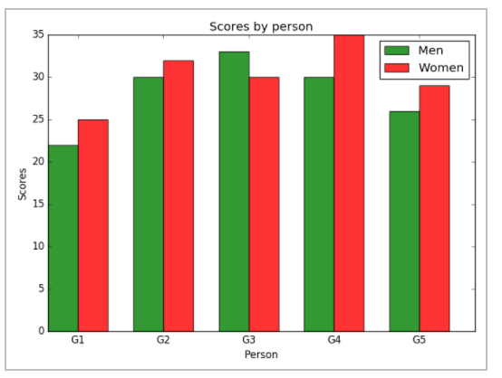

8. Write a Python programming to create a pie chart of the popularity of programming Languages.

|  |  |  |  |  |  |  |
| --- | --- | --- | --- | --- | --- | --- |
| Programming languages: | Java | Python | PHP | JavaScript | C# | C++ |
| Popularity | 22.2 | 17.6 | 8.8 | 8 | 77 | 6.7 |

9. Write a Python programming to create a pie chart of gold medal achievements of five most successful countries in 2016 Summer Olympics. Read the data from a csv file.   
Sample data:  
**medal.csv**  
country,gold_medal  
United States,46  
Great Britain,27  
China,26  
Russia,19  
Germany,17

10. Write a Python program to draw a scatter plot comparing two subject marks of Mathematics and Science. Use marks of 10 students.   
Sample data:

Test Data:  
math_marks = [88, 92, 80, 89, 100, 80, 60, 100, 80, 34]  
science_marks = [35, 79, 79, 48, 100, 88, 32, 45, 20, 30]  
marks_range = [10, 20, 30, 40, 50, 60, 70, 80, 90, 100]

